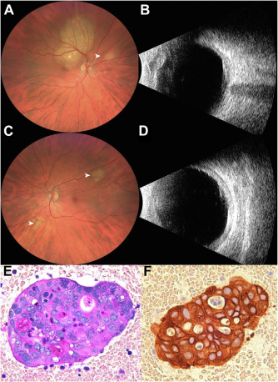

A 56-year-old White woman with history of retroperitoneal mucinous cystadenocarcinoma presented with right eye (OD) vision loss for2 weeks. Upon examination, visual acuity was 20/80 OD and 20/25 left eye (OS). Fundoscopic examination revealed a large amelanoticchoroidal mass superior to disc OD measuring 12 mm in base and 3.3 mm in thickness and a smaller superonasal choroidal mass(arrowhead) (A, B). There were 2 small choroidal tumors OS (arrowheads) (C, D). Positron emission tomography scan revealed metastaticdisease to the lungs and bones, confirmed on bone marrow aspirate by clusters of large epithelioid cells with irregular nuclei, inconspicuousnucleoli, and moderate amounts of cytoplasm containing mucin on Periodic acid-Schiff stain (E, F). Based on the provided images and clinical description please make an ophthalmic diagnosis for this patient. And output the diagnostic conclusions only.

**Bilateral choroidal metastases from retroperitoneal mucinous cystadenocarcinoma.**